Міністерство освіти і науки України

Національний університет „Львівська політехніка”

Кафедра ЕОМ



**Звіт**

З лабораторної роботи № 3

З дисципліни “Моделювання комп’ютерних систем”

На тему: “Поведінковий опис цифрового автомата. Перевірка роботи автомата за допомогою стенда”

Варіант 2

Виконав: ст.гр. КІ-201

Нескромний Д.П.

Перевірив:

асистент

Козак Н.Б.

Львів 2023

**Мета роботи :** На базі стенда Elbert V2 – Spartan 3A FPGA, реалізувати цифровий автомат для обчислення значення виразу дотримуючись наступних вимог:

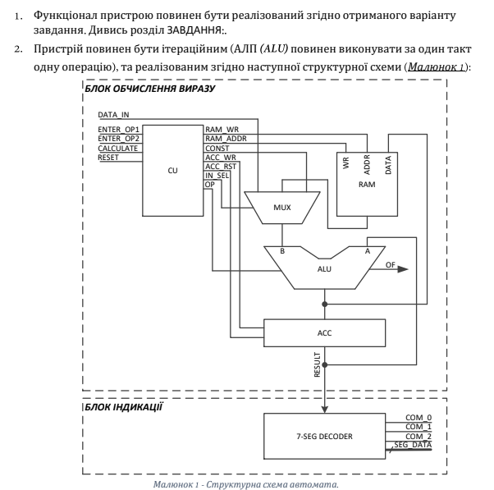

**Завдання**



**Виконання роботи:**

**Файл CU.vhd:**

**library** IEEE**;**

**use** IEEE**.**STD_LOGIC_1164**.ALL;**

-- Uncomment the following library declaration if using

-- arithmetic functions with Signed or Unsigned values

**use** IEEE**.**NUMERIC_STD**.ALL;**

**use** IEEE**.**STD_LOGIC_UNSIGNED**.ALL;**

-- Uncomment the following library declaration if instantiating

-- any Xilinx primitives in this code.

--library UNISIM;

--use UNISIM.VComponents.all;

**entity** CU_intf **is**

**port(**CLOCK **:** **IN** STD_LOGIC**;**

RESET **:** **IN** STD_LOGIC**;**

ENTER_OP1 **:** **IN** STD_LOGIC**;**

ENTER_OP2 **:** **IN** STD_LOGIC**;**

CALCULATE **:** **IN** STD_LOGIC**;**

RAM_WR **:** **OUT** STD_LOGIC**;**

RAM_ADDR_BUS **:** **OUT** STD_LOGIC_VECTOR**(**1 **downto** 0**);**

CONSTANT_BUS **:** **OUT** STD_LOGIC_VECTOR**(**7 **downto** 0**):=** "00000011"**;**

ACC_WR **:** **OUT** STD_LOGIC**;**

ACC_RST **:** **OUT** STD_LOGIC**;**

IN_SEL **:** **OUT** STD_LOGIC_VECTOR**(**1 **downto** 0**);**

OP_CODE_BUS **:** **OUT** STD_LOGIC_VECTOR**(**1 **downto** 0**)**

**);**

**end** CU_intf**;**

**architecture** CU_arch **of** CU_intf **is**

**type** cu_state_type **is** **(**cu_rst**,** cu_idle**,** cu_load_op1**,** cu_load_op2**,** cu_run_calc0**,** cu_run_calc1**,** cu_run_calc2**,** cu_run_calc3**,** cu_finish**);**

**signal** cu_cur_state **:** cu_state_type**;**

**signal** cu_next_state **:** cu_state_type**;**

**begin**

CONSTANT_BUS **<=** "00000011"**;**

CU_SYNC_PROC**:** **process** **(**CLOCK**)**

**begin**

**if** **(rising_edge(**CLOCK**))** **then**

**if** **(**RESET **=** '1'**)** **then**

cu_cur_state **<=** cu_rst**;**

**else**

cu_cur_state **<=** cu_next_state**;**

**end** **if;**

**end** **if;**

**end** **process;**

CUNEXT_STATE_DECODE**:** **process** **(**cu_cur_state**,** ENTER_OP1**,** ENTER_OP2**,** CALCULATE**)**

**begin**

--declare default state for next_state to avoid latches

cu_next_state **<=** cu_cur_state**;** --default is to stay in current state

--insert statements to decode next_state

--below is a simple example

**case(**cu_cur_state**)** **is**

**when** cu_rst **=>**

cu_next_state **<=** cu_idle**;**

**when** cu_idle **=>**

**if** **(**ENTER_OP1 **=** '1'**)** **then**

cu_next_state **<=** cu_load_op1**;**

**elsif** **(**ENTER_OP2 **=** '1'**)** **then**

cu_next_state **<=** cu_load_op2**;**

**elsif** **(**CALCULATE **=** '1'**)** **then**

cu_next_state **<=** cu_run_calc0**;**

**else**

cu_next_state **<=** cu_idle**;**

**end** **if;**

**when** cu_load_op1 **=>**

cu_next_state **<=** cu_idle**;**

**when** cu_load_op2 **=>**

cu_next_state **<=** cu_idle**;**

**when** cu_run_calc0 **=>**

cu_next_state **<=** cu_run_calc1**;**

**when** cu_run_calc1 **=>**

cu_next_state **<=** cu_run_calc2**;**

**when** cu_run_calc2 **=>**

cu_next_state **<=** cu_run_calc3**;**

**when** cu_run_calc3 **=>**

cu_next_state **<=** cu_finish**;**

**when** cu_finish **=>**

cu_next_state **<=** cu_finish**;**

**when** **others** **=>**

cu_next_state **<=** cu_idle**;**

**end** **case;**

**end** **process;**

CU_OUTPUT_DECODE**:** **process** **(**cu_cur_state**)**

**begin**

**case(**cu_cur_state**)** **is**

**when** cu_rst **=>**

IN_SEL **<=** "00"**;**

OP_CODE_BUS **<=** "00"**;**

RAM_ADDR_BUS **<=** "00"**;**

RAM_WR **<=** '0'**;**

ACC_RST **<=** '1'**;**

ACC_WR **<=** '0'**;**

**when** cu_idle **=>**

IN_SEL **<=** "00"**;**

OP_CODE_BUS **<=** "00"**;**

RAM_ADDR_BUS **<=** "00"**;**

RAM_WR **<=** '0'**;**

ACC_RST **<=** '0'**;**

ACC_WR **<=** '0'**;**

**when** cu_load_op1 **=>**

IN_SEL **<=** "00"**;**

OP_CODE_BUS **<=** "00"**;**

RAM_ADDR_BUS **<=** "00"**;**

RAM_WR **<=** '1'**;**

ACC_RST **<=** '0'**;**

ACC_WR **<=** '1'**;**

**when** cu_load_op2 **=>**

IN_SEL **<=** "00"**;**

OP_CODE_BUS **<=** "00"**;**

RAM_ADDR_BUS **<=** "01"**;**

RAM_WR **<=** '1'**;**

ACC_RST **<=** '0'**;**

ACC_WR **<=** '1'**;**

**when** cu_run_calc0 **=>**

IN_SEL **<=** "01"**;**

OP_CODE_BUS **<=** "00"**;**

RAM_ADDR_BUS **<=** "00"**;**

RAM_WR **<=** '0'**;**

ACC_RST **<=** '0'**;**

ACC_WR **<=** '1'**;**

**when** cu_run_calc1 **=>**

IN_SEL **<=** "01"**;**

OP_CODE_BUS **<=** "11"**;**

RAM_ADDR_BUS **<=** "01"**;**

RAM_WR **<=** '0'**;**

ACC_RST **<=** '0'**;**

ACC_WR **<=** '1'**;**

**when** cu_run_calc2 **=>**

IN_SEL **<=** "01"**;**

OP_CODE_BUS **<=** "01"**;**

RAM_ADDR_BUS **<=** "01"**;**

RAM_WR **<=** '0'**;**

ACC_RST **<=** '0'**;**

ACC_WR **<=** '1'**;**

**when** cu_run_calc3 **=>**

IN_SEL **<=** "10"**;**

OP_CODE_BUS **<=** "10"**;**

RAM_ADDR_BUS **<=** "01"**;**

RAM_WR **<=** '0'**;**

ACC_RST **<=** '0'**;**

ACC_WR **<=** '1'**;**

**when** cu_finish **=>**

IN_SEL **<=** "00"**;**

OP_CODE_BUS **<=** "00"**;**

RAM_ADDR_BUS **<=** "00"**;**

RAM_WR **<=** '0'**;**

ACC_RST **<=** '0'**;**

ACC_WR **<=** '0'**;**

**when** **others** **=>**

IN_SEL **<=** "00"**;**

OP_CODE_BUS **<=** "00"**;**

RAM_ADDR_BUS **<=** "00"**;**

RAM_WR **<=** '0'**;**

ACC_RST **<=** '0'**;**

ACC_WR **<=** '0'**;**

**end** **case;**

**end** **process;**

**end** CU_arch**;**

**Елемент CU:**

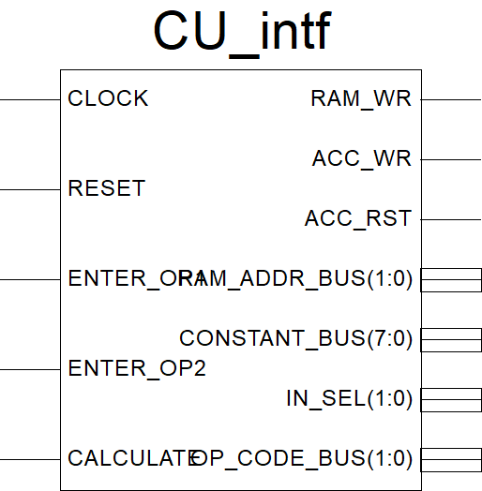

**Файл MUX.vhd:**

**library** IEEE**;**

**use** IEEE**.**STD_LOGIC_1164**.ALL;**

-- Uncomment the following library declaration if using

-- arithmetic functions with Signed or Unsigned values

**use** IEEE**.**NUMERIC_STD**.ALL;**

**use** IEEE**.**STD_LOGIC_UNSIGNED**.ALL;**

-- Uncomment the following library declaration if instantiating

-- any Xilinx primitives in this code.

--library UNISIM;

--use UNISIM.VComponents.all;

**entity** MUX_intf **is**

**port(**

DATA_IN **:** **IN** STD_LOGIC_VECTOR**(**7 **downto** 0**);**

CONSTANT_BUS **:** **IN** STD_LOGIC_VECTOR**(**7 **downto** 0**);**

RAM_DATA_OUT_BUS**:** **IN** STD_LOGIC_VECTOR**(**7 **downto** 0**);**

IN_SEL **:** **IN** STD_LOGIC_VECTOR**(**1 **downto** 0**);**

IN_SEL_OUT_BUS **:** **OUT** std_logic_vector**(**7 **downto** 0**)**

**);**

**end** MUX_intf**;**

**architecture** MUX_arch **of** MUX_intf **is**

**begin**

INSEL_A_MUX **:** **process(**DATA_IN**,** CONSTANT_BUS**,** RAM_DATA_OUT_BUS**,** IN_SEL**)**

**begin**

**if(**IN_SEL **=** "00"**)** **then**

IN_SEL_OUT_BUS **<=** DATA_IN**;**

**elsif(**IN_SEL **=** "01"**)** **then**

IN_SEL_OUT_BUS **<=** RAM_DATA_OUT_BUS**;**

**else**

IN_SEL_OUT_BUS **<=** CONSTANT_BUS**;**

**end** **if;**

**end** **process** INSEL_A_MUX**;**

**end** MUX_arch**;**

**Елемент MUX:**

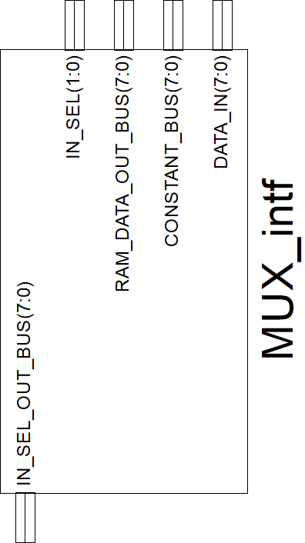

**Файл RAM.vhd:**

**library** IEEE**;**

**use** IEEE**.**STD_LOGIC_1164**.ALL;**

-- Uncomment the following library declaration if using

-- arithmetic functions with Signed or Unsigned values

**use** IEEE**.**NUMERIC_STD**.ALL;**

**use** IEEE**.**STD_LOGIC_UNSIGNED**.ALL;**

-- Uncomment the following library declaration if instantiating

-- any Xilinx primitives in this code.

--library UNISIM;

--use UNISIM.VComponents.all;

**entity** RAM_intf **is**

**port(**

RAM_WR **:** **IN** STD_LOGIC**;**

RAM_ADDR_BUS **:** **IN** STD_LOGIC_VECTOR**(**1 **downto** 0**);**

ACC_DATA_IN_BUS **:** **IN** STD_LOGIC_VECTOR**(**7 **downto** 0**);**

RAM_DATA_OUT_BUS**:** **OUT** STD_LOGIC_VECTOR**(**7 **downto** 0**);**

CLOCK **:** **IN** STD_LOGIC

**);**

**end** RAM_intf**;**

**architecture** RAM_arch **of** RAM_intf **is**

**type** ram_type **is** **array** **(**3 **downto** 0**)** **of** STD_LOGIC_VECTOR**(**7 **downto** 0**);**

**signal** RAM_UNIT **:** ram_type**;**

**signal** RAM_DATA_IN_BUS **:** STD_LOGIC_VECTOR**(**7 **downto** 0**);**

**begin**

RAM_DATA_IN_BUS **<=** ACC_DATA_IN_BUS**;**

RAM **:** **process(**CLOCK**,** RAM_ADDR_BUS**,** RAM_UNIT**)**

**begin**

**if** **(rising_edge(**CLOCK**))** **then**

**if** **(**RAM_WR **=** '1'**)** **then**

RAM_UNIT**(**conv_integer**(**RAM_ADDR_BUS**))** **<=** RAM_DATA_IN_BUS**;**

**end** **if;**

**end** **if;**

RAM_DATA_OUT_BUS **<=** RAM_UNIT**(**conv_integer**(**RAM_ADDR_BUS**));**

**end** **process** RAM**;**

**end** RAM_arch**;**

**Елемент RAM:**

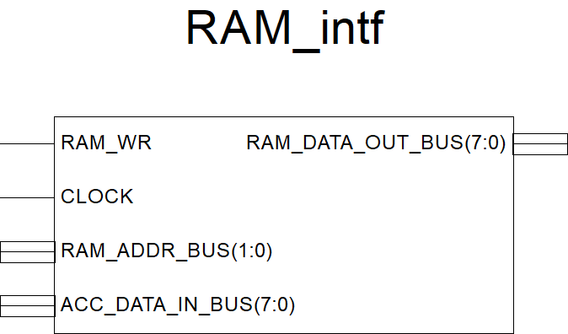

**Файл ALU.vhd:**

**library** IEEE**;**

**use** IEEE**.**STD_LOGIC_1164**.ALL;**

-- Uncomment the following library declaration if using

-- arithmetic functions with Signed or Unsigned values

**use** IEEE**.**NUMERIC_STD**.ALL;**

**use** IEEE**.**STD_LOGIC_UNSIGNED**.ALL;**

-- Uncomment the following library declaration if instantiating

-- any Xilinx primitives in this code.

--library UNISIM;

--use UNISIM.VComponents.all;

**entity** ALU_intf **is**

**port(**

IN_SEL_OUT_BUS **:** **IN** STD_LOGIC_VECTOR**(**7 **downto** 0**);**

ACC_DATA_OUT_BUS **:** **IN** STD_LOGIC_VECTOR**(**7 **downto** 0**);**

OP_CODE_BUS **:** **IN** STD_LOGIC_VECTOR**(**1 **downto** 0**);**

ACC_DATA_IN_BUS **:** **OUT** STD_LOGIC_VECTOR**(**7 **downto** 0**);**

OVER_FLOW **:** **OUT** STD_LOGIC

--OF - overflow

**);**

**end** ALU_intf**;**

**architecture** ALU_arch **of** ALU_intf **is**

**begin**

ALU **:** **process(**OP_CODE_BUS**,** IN_SEL_OUT_BUS**,** ACC_DATA_OUT_BUS**)**

**variable** A **:** unsigned**(**7 **downto** 0**);**

**variable** B **:** unsigned**(**7 **downto** 0**);**

**variable** temp **:** std_logic_vector**(**8 **downto** 0**);**

**begin**

A **:=** unsigned**(**ACC_DATA_OUT_BUS**);**

B **:=** unsigned**(**IN_SEL_OUT_BUS**);**

**if** OP_CODE_BUS **=** "00" **then**

ACC_DATA_IN_BUS **<=** STD_LOGIC_VECTOR**(**B**);**

**elsif** OP_CODE_BUS **=** "01" **then**

temp **:=** STD_LOGIC_VECTOR**(**'0' **&** A**)** **+** STD_LOGIC_VECTOR**(**'0' **&** B**);**

**if** **(**temp**(**8**)** **=** '1'**)** **then**

OVER_FLOW **<=** '1'**;**

**else**

OVER_FLOW **<=** '0'**;**

**end** **if;**

ACC_DATA_IN_BUS **<=** temp**(**7 **downto** 0**);**

**elsif** OP_CODE_BUS **=** "10" **then**

temp **:=** STD_LOGIC_VECTOR**(**'0' **&** A**)** **-** STD_LOGIC_VECTOR**(**'0' **&** B**);**

**if** **(**temp**(**8**)** **=** '1'**)** **then**

OVER_FLOW **<=** '1'**;**

**else**

OVER_FLOW **<=** '0'**;**

**end** **if;**

ACC_DATA_IN_BUS **<=** temp**(**7 **downto** 0**);**

**elsif** OP_CODE_BUS **=** "11" **then**

temp **:=** STD_LOGIC_VECTOR**(**'0' **&** A**)** **OR** STD_LOGIC_VECTOR**(**'0' **&** B**);**

ACC_DATA_IN_BUS **<=** temp**(**7 **downto** 0**);**

**else**

ACC_DATA_IN_BUS **<=** "00000000"**;**

**end** **if;**

**end** **process** ALU**;**

**end** ALU_arch**;**

**Елемент ALU:**

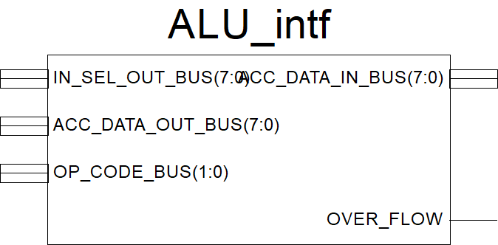

**Файл ACC.vhd:**

**library** IEEE**;**

**use** IEEE**.**STD_LOGIC_1164**.ALL;**

-- Uncomment the following library declaration if using

-- arithmetic functions with Signed or Unsigned values

**use** IEEE**.**NUMERIC_STD**.ALL;**

**use** IEEE**.**STD_LOGIC_UNSIGNED**.ALL;**

-- Uncomment the following library declaration if instantiating

-- any Xilinx primitives in this code.

--library UNISIM;

--use UNISIM.VComponents.all;

**entity** ACC_intf **is**

**port(**

CLOCK **:** **IN** STD_LOGIC**;**

ACC_RST **:** **IN** STD_LOGIC**;**

ACC_WR **:** **IN** STD_LOGIC**;**

ACC_DATA_IN_BUS **:** **IN** STD_LOGIC_VECTOR**(**7 **downto** 0**);**

ACC_DATA_OUT_BUS **:** **OUT** STD_LOGIC_VECTOR**(**7 **downto** 0**)**

**);**

**end** ACC_intf**;**

**architecture** ACC_arch **of** ACC_intf **is**

**signal** ACC_DATA **:** STD_LOGIC_VECTOR**(**7 **downto** 0**);**

**begin**

ACC **:** **process(**CLOCK**,** ACC_DATA**)**

**begin**

**if** **(rising_edge(**CLOCK**))** **then**

**if(**ACC_RST **=** '1'**)** **then**

ACC_DATA **<=** "00000000"**;**

**elsif** **(**ACC_WR **=** '1'**)** **then**

ACC_DATA **<=** ACC_DATA_IN_BUS**;**

**end** **if;**

**end** **if;**

ACC_DATA_OUT_BUS **<=** ACC_DATA**;**

**end** **process** ACC**;**

**end** ACC_arch**;**

**Елемент ACC:**

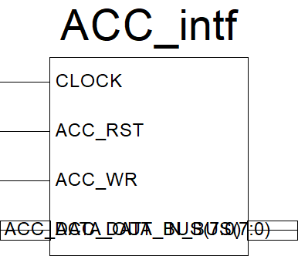

**Файл SEGDEC.vhd:**

**library** IEEE**;**

**use** IEEE**.**STD_LOGIC_1164**.ALL;**

-- Uncomment the following library declaration if using

-- arithmetic functions with Signed or Unsigned values

**use** IEEE**.**NUMERIC_STD**.ALL;**

**use** IEEE**.**STD_LOGIC_UNSIGNED**.ALL;**

-- Uncomment the following library declaration if instantiating

-- any Xilinx primitives in this code.

--library UNISIM;

--use UNISIM.VComponents.all;

**entity** SEGDEC_intf **is**

**port(**

CLOCK **:** **IN** STD_LOGIC**;**

ACC_DATA_OUT_BUS **:** **IN** STD_LOGIC_VECTOR**(**7 **downto** 0**);**

RESET **:** **IN** STD_LOGIC**;**

OverFlow_IN **:** **IN** STD_LOGIC**;**

COMM_ONES **:** **OUT** STD_LOGIC**;**

COMM_DECS **:** **OUT** STD_LOGIC**;**

COMM_HUNDREDS **:** **OUT** STD_LOGIC**;**

SEG_A **:** **OUT** STD_LOGIC**;**

SEG_B **:** **OUT** STD_LOGIC**;**

SEG_C **:** **OUT** STD_LOGIC**;**

SEG_D **:** **OUT** STD_LOGIC**;**

SEG_E **:** **OUT** STD_LOGIC**;**

SEG_F **:** **OUT** STD_LOGIC**;**

SEG_G **:** **OUT** STD_LOGIC**;**

DP **:** **OUT** STD_LOGIC**;**

OverFlow_OUT **:** **OUT** STD_LOGIC **:=** '0'

**);**

**end** SEGDEC_intf**;**

**architecture** SEGDEC_arch **of** SEGDEC_intf **is**

**signal** ONES_BUS **:** STD_LOGIC_VECTOR**(**3 **downto** 0**)** **:=** "0000"**;**

**signal** DECS_BUS **:** STD_LOGIC_VECTOR**(**3 **downto** 0**)** **:=** "0000"**;**

**signal** HONDREDS_BUS **:** STD_LOGIC_VECTOR**(**3 **downto** 0**)** **:=** "0000"**;**

**begin**

OVERFLOW_INDICATE **:** **process(**OverFlow_IN**,** RESET**)**

**begin**

--if rising_edge(CLOCK) then

**if** **(**RESET **=** '1'**)** **then**

OverFlow_OUT **<=** '0'**;**

**elsif** **(**RESET **=** '0' **and** OverFlow_IN **=** '1'**)** **then**

OverFlow_OUT **<=** '1'**;**

**end** **if;**

--end if;

**end** **process** OVERFLOW_INDICATE**;**

BIN_TO_BCD **:** **process** **(**ACC_DATA_OUT_BUS**)**

**variable** hex_src **:** STD_LOGIC_VECTOR**(**7 **downto** 0**)** **;**

**variable** bcd **:** STD_LOGIC_VECTOR**(**11 **downto** 0**)** **;**

**begin**

bcd **:=** **(others** **=>** '0'**)** **;**

hex_src **:=** ACC_DATA_OUT_BUS**;**

**for** i **in** hex_src'**range** **loop**

**if** bcd**(**3 **downto** 0**)** **>** "0100" **then**

bcd**(**3 **downto** 0**)** **:=** bcd**(**3 **downto** 0**)** **+** "0011" **;**

**end** **if** **;**

**if** bcd**(**7 **downto** 4**)** **>** "0100" **then**

bcd**(**7 **downto** 4**)** **:=** bcd**(**7 **downto** 4**)** **+** "0011" **;**

**end** **if** **;**

**if** bcd**(**11 **downto** 8**)** **>** "0100" **then**

bcd**(**11 **downto** 8**)** **:=** bcd**(**11 **downto** 8**)** **+** "0011" **;**

**end** **if** **;**

bcd **:=** bcd**(**10 **downto** 0**)** **&** hex_src**(**hex_src'**left)** **;** -- shift bcd + 1 new entry

hex_src **:=** hex_src**(**hex_src'**left** **-** 1 **downto** hex_src'**right)** **&** '0' **;** -- shift src + pad with 0

**end** **loop** **;**

HONDREDS_BUS **<=** bcd **(**11 **downto** 8**);**

DECS_BUS **<=** bcd **(**7 **downto** 4**);**

ONES_BUS **<=** bcd **(**3 **downto** 0**);**

**end** **process** BIN_TO_BCD**;**

INDICATE **:** **process(**CLOCK**)**

**type** DIGIT_TYPE **is** **(**ONES**,** DECS**,** HUNDREDS**);**

**variable** CUR_DIGIT **:** DIGIT_TYPE **:=** ONES**;**

**variable** DIGIT_VAL **:** STD_LOGIC_VECTOR**(**3 **downto** 0**)** **:=** "0000"**;**

**variable** DIGIT_CTRL **:** STD_LOGIC_VECTOR**(**6 **downto** 0**)** **:=** "0000000"**;**

**variable** COMMONS_CTRL **:** STD_LOGIC_VECTOR**(**2 **downto** 0**)** **:=** "000"**;**

**begin**

**if** **(rising_edge(**CLOCK**))** **then**

**if(**RESET **=** '0'**)** **then**

**case** CUR_DIGIT **is**

**when** ONES **=>**

DIGIT_VAL **:=** ONES_BUS**;**

CUR_DIGIT **:=** DECS**;**

COMMONS_CTRL **:=** "001"**;**

**when** DECS **=>**

DIGIT_VAL **:=** DECS_BUS**;**

CUR_DIGIT **:=** HUNDREDS**;**

COMMONS_CTRL **:=** "010"**;**

**when** HUNDREDS **=>**

DIGIT_VAL **:=** HONDREDS_BUS**;**

CUR_DIGIT **:=** ONES**;**

COMMONS_CTRL **:=** "100"**;**

**when** **others** **=>**

DIGIT_VAL **:=** ONES_BUS**;**

CUR_DIGIT **:=** ONES**;**

COMMONS_CTRL **:=** "000"**;**

**end** **case;**

**case** DIGIT_VAL **is** --abcdefg

**when** "0000" **=>** DIGIT_CTRL **:=** "1111110"**;**

**when** "0001" **=>** DIGIT_CTRL **:=** "0110000"**;**

**when** "0010" **=>** DIGIT_CTRL **:=** "1101101"**;**

**when** "0011" **=>** DIGIT_CTRL **:=** "1111001"**;**

**when** "0100" **=>** DIGIT_CTRL **:=** "0110011"**;**

**when** "0101" **=>** DIGIT_CTRL **:=** "1011011"**;**

**when** "0110" **=>** DIGIT_CTRL **:=** "1011111"**;**

**when** "0111" **=>** DIGIT_CTRL **:=** "1110000"**;**

**when** "1000" **=>** DIGIT_CTRL **:=** "1111111"**;**

**when** "1001" **=>** DIGIT_CTRL **:=** "1111011"**;**

**when** **others** **=>** DIGIT_CTRL **:=** "0000000"**;**

**end** **case;**

**else**

DIGIT_VAL **:=** ONES_BUS**;**

CUR_DIGIT **:=** ONES**;**

COMMONS_CTRL **:=** "000"**;**

**end** **if;**

COMM_ONES **<=** COMMONS_CTRL**(**0**);**

COMM_DECS **<=** COMMONS_CTRL**(**1**);**

COMM_HUNDREDS **<=** COMMONS_CTRL**(**2**);**

SEG_A **<=** DIGIT_CTRL**(**6**);**

SEG_B **<=** DIGIT_CTRL**(**5**);**

SEG_C **<=** DIGIT_CTRL**(**4**);**

SEG_D **<=** DIGIT_CTRL**(**3**);**

SEG_E **<=** DIGIT_CTRL**(**2**);**

SEG_F **<=** DIGIT_CTRL**(**1**);**

SEG_G **<=** DIGIT_CTRL**(**0**);**

DP **<=** '0'**;**

**end** **if;**

**end** **process** INDICATE**;**

**end** SEGDEC_arch**;**

**Елемент SEGDEC:**

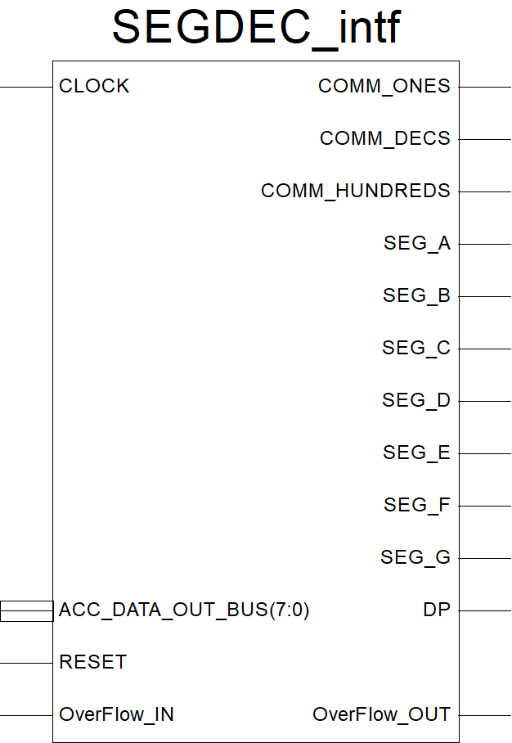

**Схема для Top Level:**

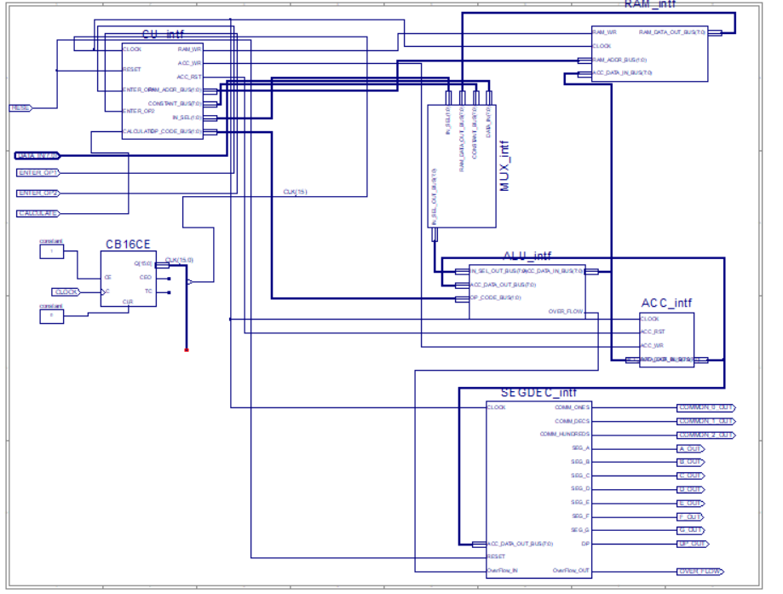

**Файл Constraints.ucf:**

#**************************************************************************************************************************************************#

# UCF for ElbertV2 Development Board #

#**************************************************************************************************************************************************#

CONFIG VCCAUX = "3.3" ;

# Clock 12 MHz

NET "CLOCK" LOC = P129 | IOSTANDARD = LVCMOS33 | PERIOD = 12MHz;

####################################################################################################

# LED

####################################################################################################

NET "OVERFLOW" LOC = P46 | IOSTANDARD = LVCMOS33 | SLEW = SLOW | DRIVE = 12;

####################################################################################################

# Seven Segment Display

####################################################################################################

NET "A_OUT" LOC = P117 | IOSTANDARD = LVCMOS33 | SLEW = SLOW | DRIVE = 12;

NET "B_OUT" LOC = P116 | IOSTANDARD = LVCMOS33 | SLEW = SLOW | DRIVE = 12;

NET "C_OUT" LOC = P115 | IOSTANDARD = LVCMOS33 | SLEW = SLOW | DRIVE = 12;

NET "D_OUT" LOC = P113 | IOSTANDARD = LVCMOS33 | SLEW = SLOW | DRIVE = 12;

NET "E_OUT" LOC = P112 | IOSTANDARD = LVCMOS33 | SLEW = SLOW | DRIVE = 12;

NET "F_OUT" LOC = P111 | IOSTANDARD = LVCMOS33 | SLEW = SLOW | DRIVE = 12;

NET "G_OUT" LOC = P110 | IOSTANDARD = LVCMOS33 | SLEW = SLOW | DRIVE = 12;

NET "DP_OUT" LOC = P114 | IOSTANDARD = LVCMOS33 | SLEW = SLOW | DRIVE = 12;

NET "COMMON_2_OUT" LOC = P124 | IOSTANDARD = LVCMOS33 | SLEW = SLOW | DRIVE = 12;

NET "COMMON_1_OUT" LOC = P121 | IOSTANDARD = LVCMOS33 | SLEW = SLOW | DRIVE = 12;

NET "COMMON_0_OUT" LOC = P120 | IOSTANDARD = LVCMOS33 | SLEW = SLOW | DRIVE = 12;

####################################################################################################

# DP Switches

####################################################################################################

NET "DATA_IN(0)" LOC = P70 | PULLUP | IOSTANDARD = LVCMOS33 | SLEW = SLOW | DRIVE = 12;

NET "DATA_IN(1)" LOC = P69 | PULLUP | IOSTANDARD = LVCMOS33 | SLEW = SLOW | DRIVE = 12;

NET "DATA_IN(2)" LOC = P68 | PULLUP | IOSTANDARD = LVCMOS33 | SLEW = SLOW | DRIVE = 12;

NET "DATA_IN(3)" LOC = P64 | PULLUP | IOSTANDARD = LVCMOS33 | SLEW = SLOW | DRIVE = 12;

NET "DATA_IN(4)" LOC = P63 | PULLUP | IOSTANDARD = LVCMOS33 | SLEW = SLOW | DRIVE = 12;

NET "DATA_IN(5)" LOC = P60 | PULLUP | IOSTANDARD = LVCMOS33 | SLEW = SLOW | DRIVE = 12;

NET "DATA_IN(6)" LOC = P59 | PULLUP | IOSTANDARD = LVCMOS33 | SLEW = SLOW | DRIVE = 12;

NET "DATA_IN(7)" LOC = P58 | PULLUP | IOSTANDARD = LVCMOS33 | SLEW = SLOW | DRIVE = 12;

####################################################################################################

# Switches

####################################################################################################

NET "ENTER_OP1" LOC = P80 | PULLUP | IOSTANDARD = LVCMOS33 | SLEW = SLOW | DRIVE = 12;

NET "ENTER_OP2" LOC = P79 | PULLUP | IOSTANDARD = LVCMOS33 | SLEW = SLOW | DRIVE = 12;

NET "CALCULATE" LOC = P78 | PULLUP | IOSTANDARD = LVCMOS33 | SLEW = SLOW | DRIVE = 12;

NET "RESET" LOC = P75 | PULLUP | IOSTANDARD = LVCMOS33 | SLEW = SLOW | DRIVE = 12;

####################################################################################################

**Файл TestTopLevel.vhd:**

**LIBRARY** ieee**;**

**USE** ieee**.**std_logic_1164**.ALL;**

**USE** ieee**.**numeric_std**.ALL;**

**LIBRARY** UNISIM**;**

**USE** UNISIM**.**Vcomponents**.ALL;**

**ENTITY** TopLevel_TopLevel_sch_tb **IS**

**END** TopLevel_TopLevel_sch_tb**;**

**ARCHITECTURE** behavioral **OF** TopLevel_TopLevel_sch_tb **IS**

**COMPONENT** TopLevel

**PORT(** RESE **:** **IN** STD_LOGIC**;**

ENTER_OP1 **:** **IN** STD_LOGIC**;**

ENTER_OP2 **:** **IN** STD_LOGIC**;**

CALCULATE **:** **IN** STD_LOGIC**;**

COMMON_0_OUT **:** **OUT** STD_LOGIC**;**

COMMON_1_OUT **:** **OUT** STD_LOGIC**;**

COMMON_2_OUT **:** **OUT** STD_LOGIC**;**

A_OUT **:** **OUT** STD_LOGIC**;**

B_OUT **:** **OUT** STD_LOGIC**;**

C_OUT **:** **OUT** STD_LOGIC**;**

D_OUT **:** **OUT** STD_LOGIC**;**

E_OUT **:** **OUT** STD_LOGIC**;**

F_OUT **:** **OUT** STD_LOGIC**;**

G_OUT **:** **OUT** STD_LOGIC**;**

DP_OUT **:** **OUT** STD_LOGIC**;**

CLOCK **:** **IN** STD_LOGIC**;**

DATA_IN **:** **IN** STD_LOGIC_VECTOR **(**7 **DOWNTO** 0**);**

OVER_FLOW **:** **OUT** STD_LOGIC**);**

**END** **COMPONENT;**

**signal** op1 **:** STD_LOGIC_VECTOR**(**7 **DOWNTO** 0**);**

**signal** op2 **:** STD_LOGIC_VECTOR**(**7 **DOWNTO** 0**);**

**SIGNAL** RESE **:** STD_LOGIC**;**

**SIGNAL** ENTER_OP1 **:** STD_LOGIC**;**

**SIGNAL** ENTER_OP2 **:** STD_LOGIC**;**

**SIGNAL** CALCULATE **:** STD_LOGIC**;**

**SIGNAL** COMMON_0_OUT **:** STD_LOGIC**;**

**SIGNAL** COMMON_1_OUT **:** STD_LOGIC**;**

**SIGNAL** COMMON_2_OUT **:** STD_LOGIC**;**

**SIGNAL** A_OUT **:** STD_LOGIC**;**

**SIGNAL** B_OUT **:** STD_LOGIC**;**

**SIGNAL** C_OUT **:** STD_LOGIC**;**

**SIGNAL** D_OUT **:** STD_LOGIC**;**

**SIGNAL** E_OUT **:** STD_LOGIC**;**

**SIGNAL** F_OUT **:** STD_LOGIC**;**

**SIGNAL** G_OUT **:** STD_LOGIC**;**

**SIGNAL** DP_OUT **:** STD_LOGIC**;**

**SIGNAL** CLOCK **:** STD_LOGIC**;**

**SIGNAL** DATA_IN **:** STD_LOGIC_VECTOR **(**7 **DOWNTO** 0**);**

**SIGNAL** OVER_FLOW **:** STD_LOGIC**;**

**constant** CLK_period**:** time **:=** 1 us**;**

**constant** TC_period**:** time **:=** 65536 us**;**

**BEGIN**

UUT**:** TopLevel **PORT** **MAP(**

RESE **=>** RESE**,**

ENTER_OP1 **=>** ENTER_OP1**,**

ENTER_OP2 **=>** ENTER_OP2**,**

CALCULATE **=>** CALCULATE**,**

COMMON_0_OUT **=>** COMMON_0_OUT**,**

COMMON_1_OUT **=>** COMMON_1_OUT**,**

COMMON_2_OUT **=>** COMMON_2_OUT**,**

A_OUT **=>** A_OUT**,**

B_OUT **=>** B_OUT**,**

C_OUT **=>** C_OUT**,**

D_OUT **=>** D_OUT**,**

E_OUT **=>** E_OUT**,**

F_OUT **=>** F_OUT**,**

G_OUT **=>** G_OUT**,**

DP_OUT **=>** DP_OUT**,**

CLOCK **=>** CLOCK**,**

DATA_IN **=>** DATA_IN**,**

OVER_FLOW **=>** OVER_FLOW

**);**

CLK_process **:** **process**

**begin**

CLOCK **<=** '1'**;**

**wait** **for** CLK_period**/**2**;**

CLOCK **<=** '0'**;**

**wait** **for** CLK_period**/**2**;**

**end** **process** CLK_process**;**

stim_proc**:** **process**

**begin**

RESE **<=** '1'**;**

ENTER_OP1 **<=** '0'**;**

ENTER_OP2 **<=** '0'**;**

CALCULATE **<=** '0'**;**

DATA_IN **<=(others** **=>** '0'**);**

**wait** **for** 2**\***CLK_period**;**

RESE **<=**'0'**;**

**wait** **for** 4**\***TC_period**;**

ENTER_OP1 **<=**'1'**;**

DATA_IN **<=** op1**;**

**wait** **for** 2**\***TC_period**;**

ENTER_OP1 **<=**'0'**;**

**wait** **for** 4**\***TC_period**;**

ENTER_OP2 **<=**'1'**;**

DATA_IN **<=** op2**;**

**wait** **for** 2**\***TC_period**;**

ENTER_OP2 **<=**'0'**;**

**wait** **for** 4**\***TC_period**;**

CALCULATE **<=** '1'**;**

**wait** **for** 8**\***TC_period**;**

**wait;**

**end** **process** stim_proc**;** --1.835 s

**END;**

**Перевірка результату**

OP1=00000100;

OP2=00001000;

((OP1 or OP2) + OP2) – 3 = 00010001;

1)OP1 or OP2 = 00000100 or 00001000 = 00001100;

2) (OP1 or OP2) + OP2 = 00001100 + 00001000 = 00010100;

3) ((OP1 or OP2) + OP2) – 3 = 00010100 – 3 = 00010001;

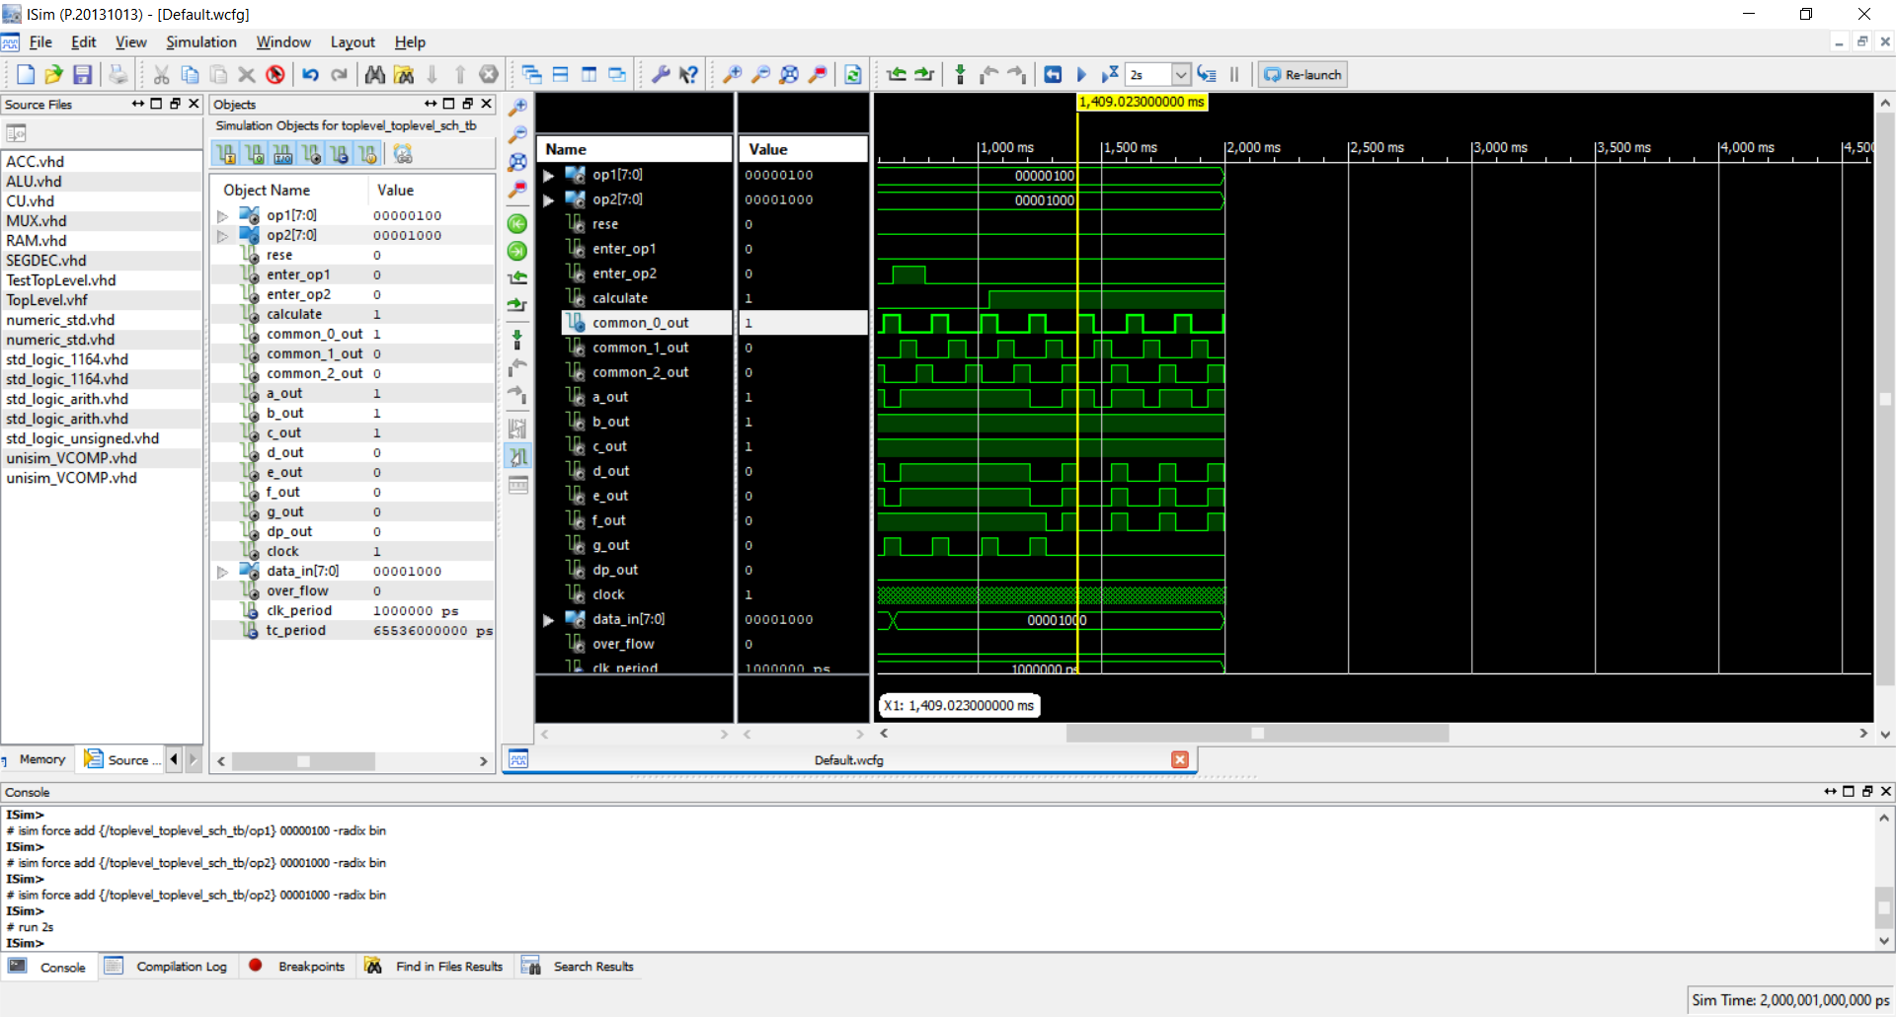

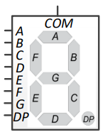

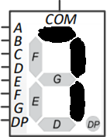

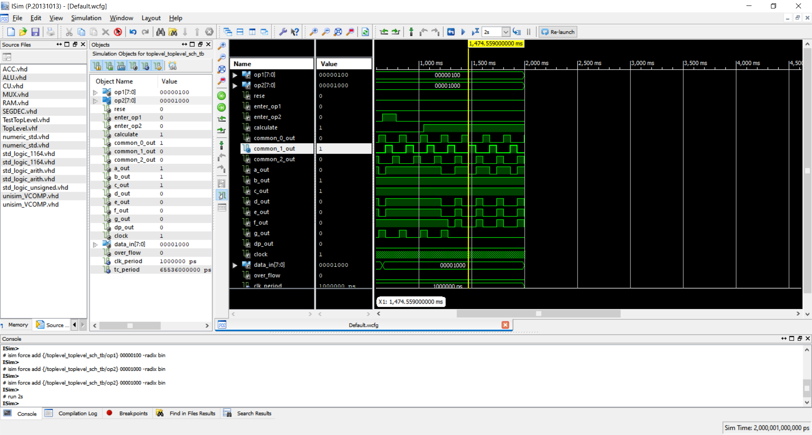

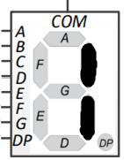

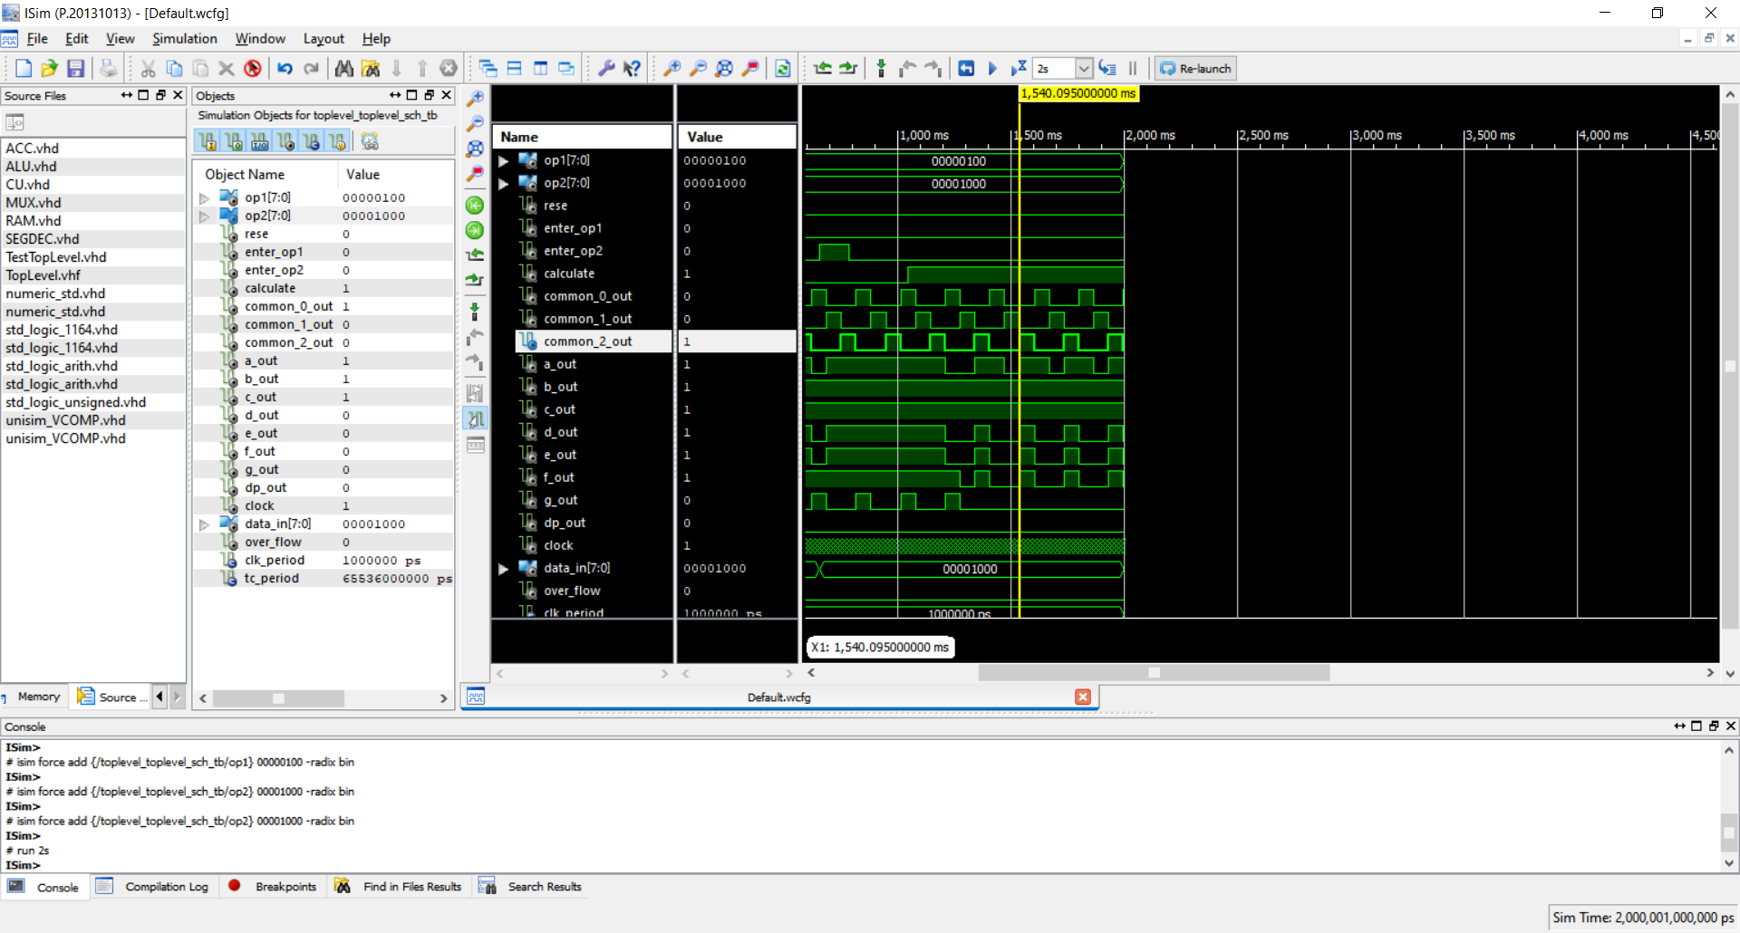

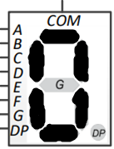

**Висновок:** Під час даної лабораторної роботи, я на базі стенда Elbert V2 – Spartan 3A FPGA, реалізував цифровий автомат для обчислення значення заданого виразу.